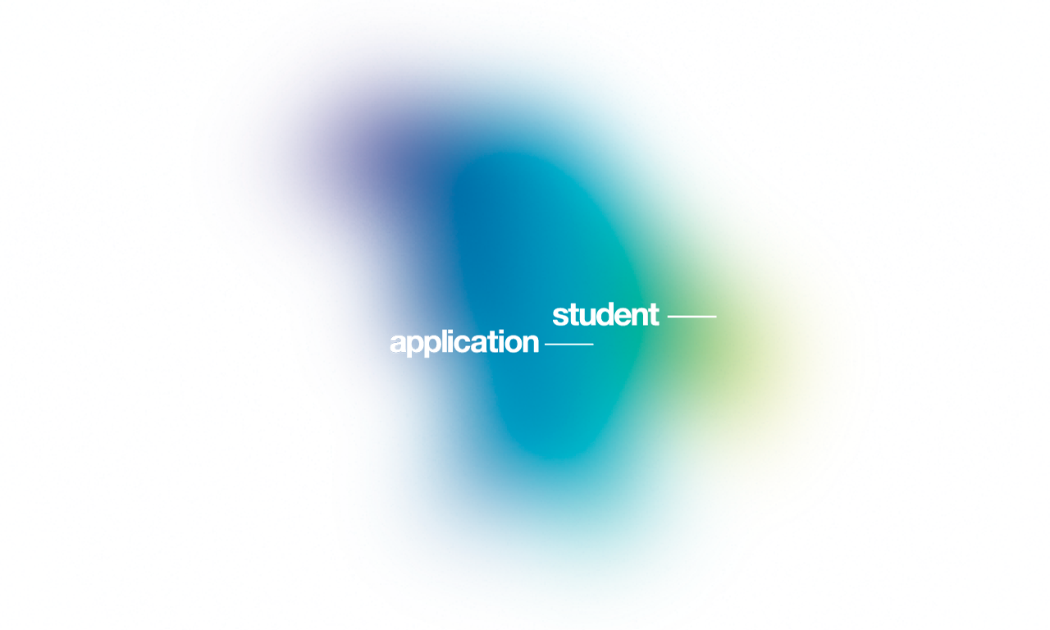

Name of School:
Name and Surname:
Date of Birth:
Title of Competing Work:
Year of Production:
Size of Work [approximately in cm]
Technique:
Category:
Student Contact:

Please send the application in electronic form (Word) until February 3rd,2017.

Jaroslav Johan Polanecký
Faculty of Art and Design
J. E. Purkyně University
Pasteurova 9
400 01 Ústí nad Labem
Czech Republic

e-mail: jpolaneck@post.cz / jaroslav.polanecky@ujep.cz
tel.: +420 733 127 829

